习题7-3：计算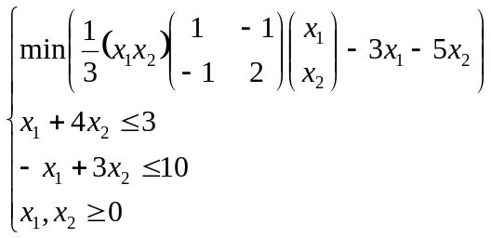的线性规划。
参照【例8-28】计算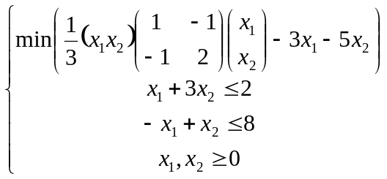的线性规划。
在命令窗口中输入如下语句：
H = [1 -1; -1 2];
f = [-3; -5];
A = [1 3;-1 2];
b = [2; 8];
[x,fval] = quadprog(H,f,A,b,[],[],[0;0])
命令窗口中的输出结果如下：
Warning: Large-scale method does not currently solve this problem formulation,
using medium-scale method instead.
> In quadprog at 263
Optimization terminated.
x =
1.2941
0.2353
fval =
-4.4706

